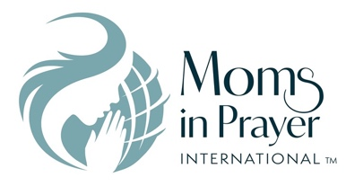 **Prayer Sheet**

**Date: ________**

Recommended: Bible, Moms in Prayer-booklet, start and end on time.

**Praise**—Praising God for **who He is**, His attributes, His name or His character.  *Please no answers to prayer or prayer requests during this time.*

**Attribute:** _____________________________________________________________________________

**Definition:** _____________________________________________________________________________

**Scripture(s):** ___________________________________________________________________________

**Confession**—Silently confessing your sins to the God who forgives.

*If we confess our sins, He is faithful and righteous to forgive us our sins and to cleanse us from all unrighteousness.* 1 John 1:9 (NASB)

**Thanksgiving**—Thanking God for **what He has done.**  *Please no prayer requests during this time.*

*In everything give thanks; for this is God’s will for you in Christ Jesus.* 1 Thessalonians 5:18 (NASB)

**Intercession**—Coming to God in prayer on behalf of others. *Form groups of two or three.*

**Our Own Children**—Each mom chooses one child. First pray the scripture then pray a specific request.

**Scripture**: _____________________________________________________________________________

1st Mom’s Child specific request: ___________________________________________________________

2nd Mom’s Child specific request: ___________________________________________________________

3rd Mom’s Child specific request: ___________________________________________________________

**Teachers/Staff**

*Open __________’s eyes and turn him/her from darkness to light and from the power of Satan to God, so that he/she may receive forgiveness of sins and a place among those who are sanctified by faith in Jesus.* From Acts 26:18

**Other scripture:** ________________________________________________________________________

**Specific Request**: _______________________________________________________________________

**School Concerns:** Revival and spiritual awakening on the school campus

**Other concerns**: ________________________________________________________________________

**Moms in Prayer Concerns** - Every school covered in prayer; protect the ministry keeping it untarnished and pure.

***Remember, what is prayed in the group, stays in the group!***