
Praise—Praising God for who He is, His attributes, His name or His character
Attribute: God is our Teacher
Definition: One who guides, instructs, and imparts knowledge
Scripture(s): Job 36:22; Psalm 32:8; Isaiah 48:17
Confession—Silently confessing your sins to the God who forgives
If we confess our sins, He is faithful and righteous to forgive us our sins and to cleanse us from all unrighteousness. 1 John 1:9 (NASB)
Thanksgiving—Thanking God for what He has done
In everything give thanks; for this is God’s will for you in Christ Jesus. 1 Thessalonians 5:18 (NASB)
Intercession—Coming to God in prayer on behalf of others
Our Own Children—Each mom chooses one child. First pray the scripture then pray a specific request.
Scripture: LORD, may You show ________ Your ways and teach him/her Your paths. May You guide ________ in Your truth and teach him/her. May You be ________’s God, his/her Savior, and may his/her hope be in You all day long. From Psalm 25:4-5
1st Mom’s Child specific request:

2nd Mom’s Child specific request:

3rd Mom’s Child specific request:
Teachers/Staff—Use the verse below or the verse for your child.
Scripture: Open __________’s eyes and turn him/her from darkness to light, and from the power of Satan to God, so that he/she may receive forgiveness of sins and a place among those who are sanctified by faith in Jesus. From Acts 26:18
School Concerns
- Pray for revival and spiritual awakening at your school.
- Pray for protection over the staff and students at your school.
- Pray for other concerns at your school.
Moms in Prayer Concerns
- Pray that every school worldwide would be covered in prayer.
- Pray for protection over the ministry, keeping it pure and unified.
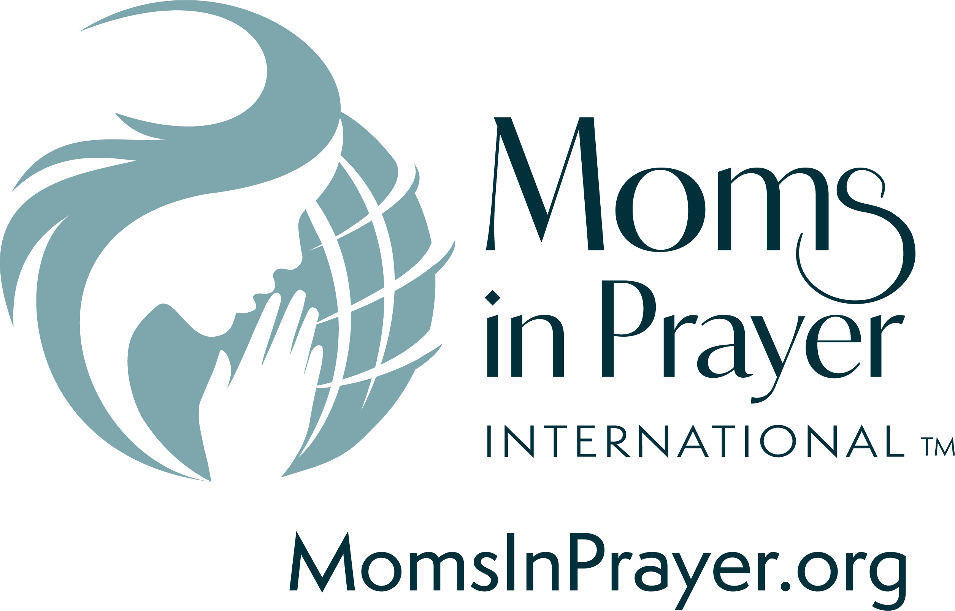
- Pray for more donors to partner with the ministry in equipping groups
and reaching the nations.
Remember, what is prayed in the group, stays in the group!

